ST. XAVIER’S COLLEGE

**Maitighar, Kathmandu**

**(Affiliated to Tribhuvan University)**



**Computer Graphics**

**Lab Assignment #9**

**SHEAR AN IMAGE ON X-AXIS AND Y-AXIS IN C++ BUILDER**

**Submitted By**

Alok Shrestha

013BSCIT005

B.Sc. CSIT Year II/IV Semester

**Submitted To**

Er. Anil Shah

Lecturer

Department of Computer Science

St. Xavier’s College

Maitighar, Kathmandu

**Submitted On**

September 2015

**STATEMENT**

**SHEAR AN IMAGE ON X-AXIS AND Y-AXIS IN C++ BUILDER**

**ALGORITHM**

**For Reflection**

1. Get the width and height of the source image
2. Get parameters for shearing (shx and shy)
3. For each point i in width

For each point j in height

The translated point (x’, y’) is given by

x' = i + j*shy;

y’ = j + i*shx;

Plot the points (x’, y’) with the same color as source in destination

1. Stop

**SOURCE CODE**

//---------------------------------------------------------------------------

#include <vcl\vcl.h>

#pragma hdrstop

#include "Unit1.h"

//---------------------------------------------------------------------------

#pragma resource "*.dfm"

TForm1 *Form1;

int x, y;

/*By aalooksth@inbox.com*/

//---------------------------------------------------------------------------

__fastcall TForm1::TForm1(TComponent* Owner)

: TForm(Owner)

{

}

//---------------------------------------------------------------------------

void __fastcall TForm1::Button1Click(TObject *Sender)

{

x = Image1->Width;

y = Image1->Height;

int shx=StrToInt(Edit1->Text);

int shy=StrToInt(Edit2->Text);

int a, b;

for(int i=0; i<=x; i++)

{

for(int j=0; j<=y; j++)

{

a=i+j*shx;

b=j+i*shy;

Image2->Canvas->Pixels[a][b]=Image1->Canvas->Pixels[i][j];

}

}

}

//---------------------------------------------------------------------------

**OUTPUT/s**

**Shear along x-axis (shy=0)**

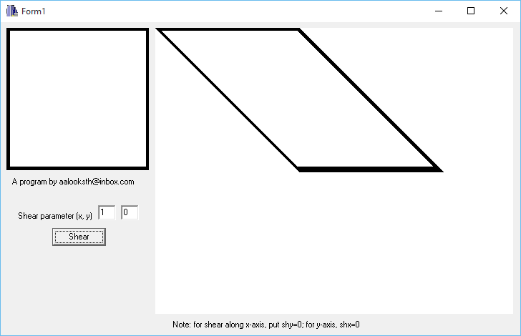

**Shear on y-axis (shx=0)**

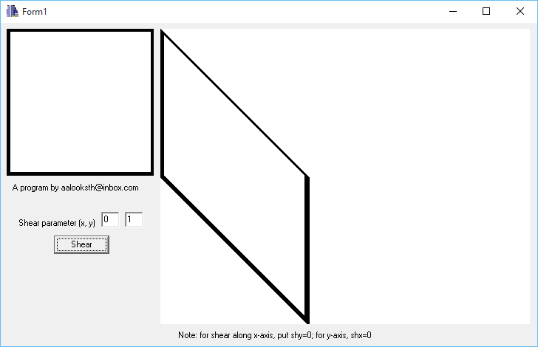

**CONCLUSION**

Hence, the shearing of the image were performed in x-axis and y-axis in C++builder.